The AmazonS3ReadOnlyAccess Policy
The resource “*” is a wild card that basically means “All Resources”
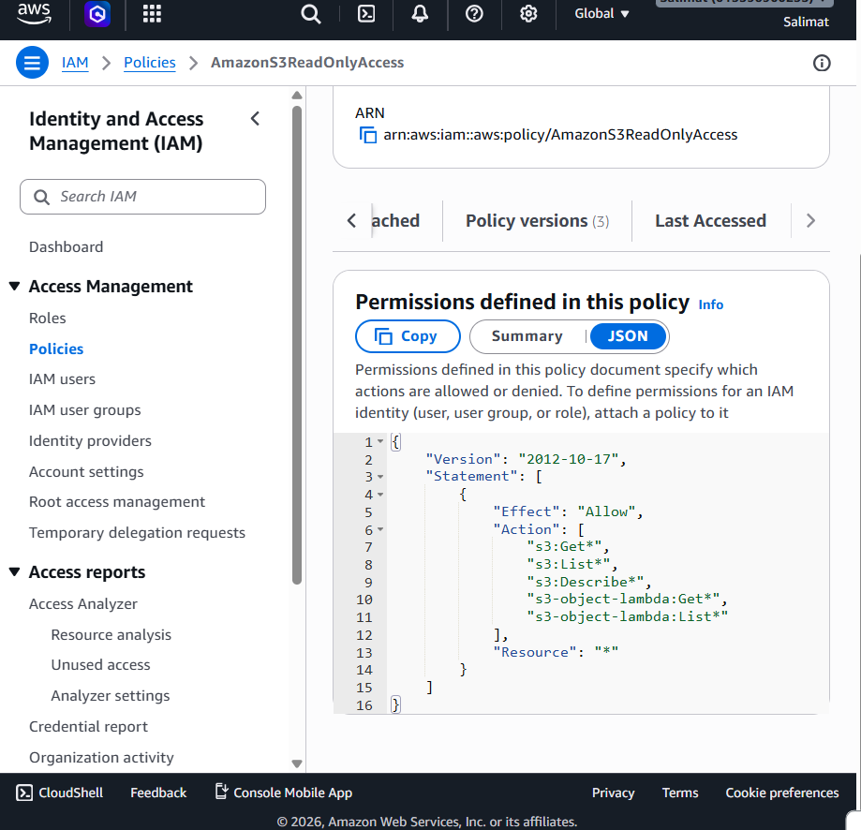
S3-AppBucket-ReadOnly-NoDeletion
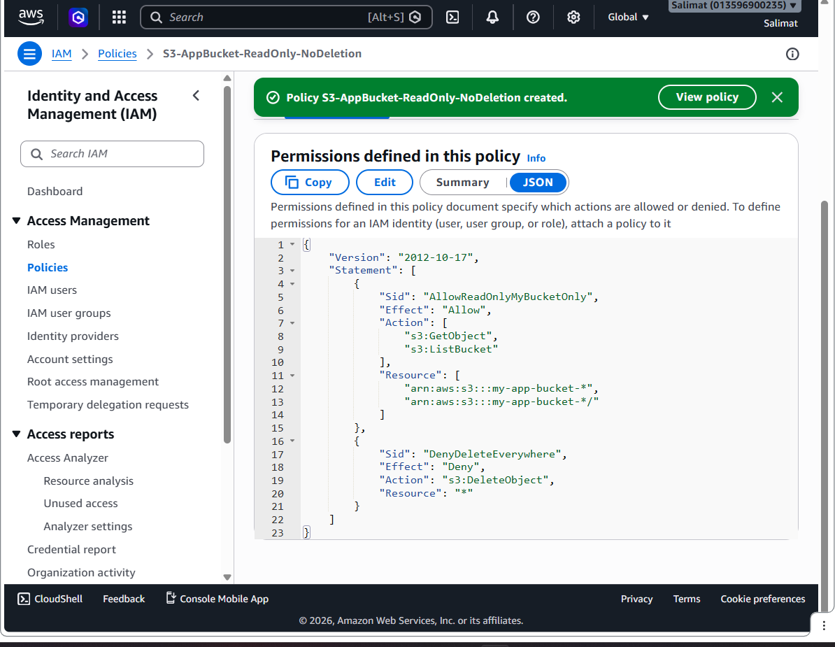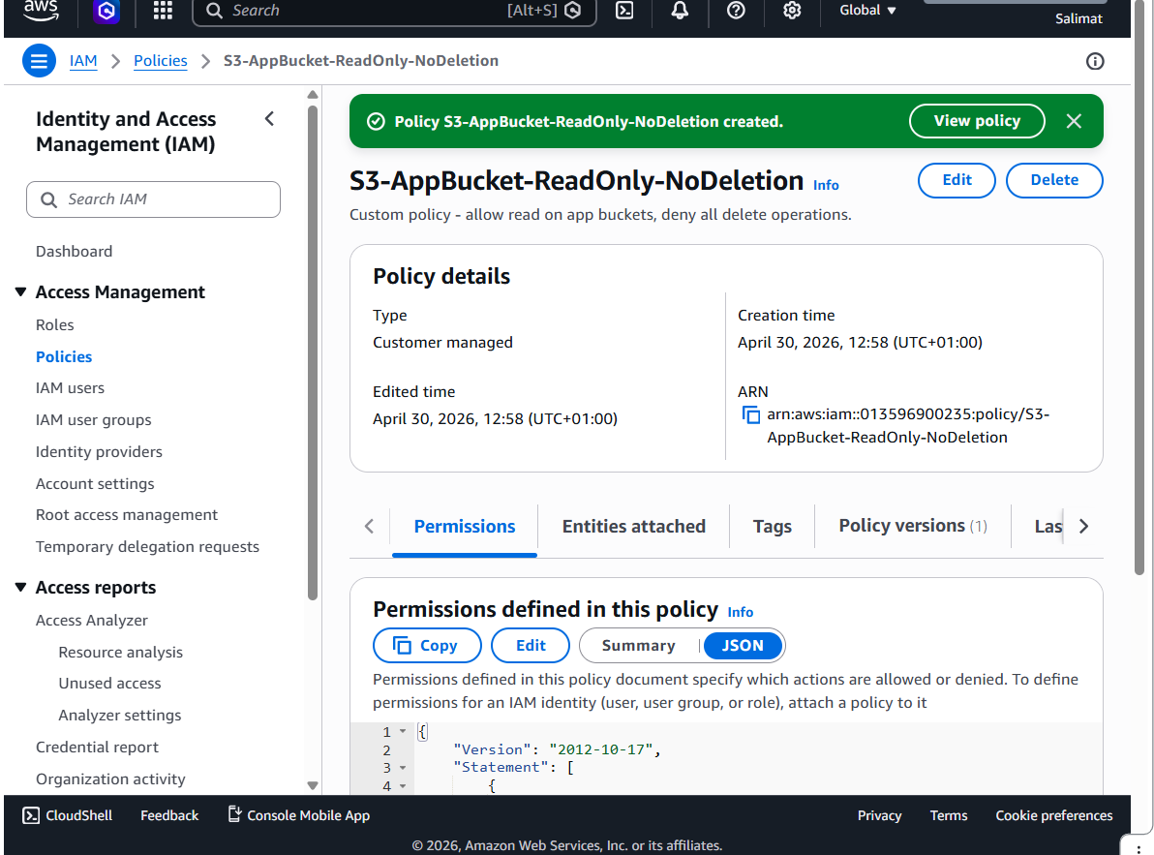
Adding the “S3-AppBucket-ReadOnly-NoDeletion” policy to the “analyst-user” permission
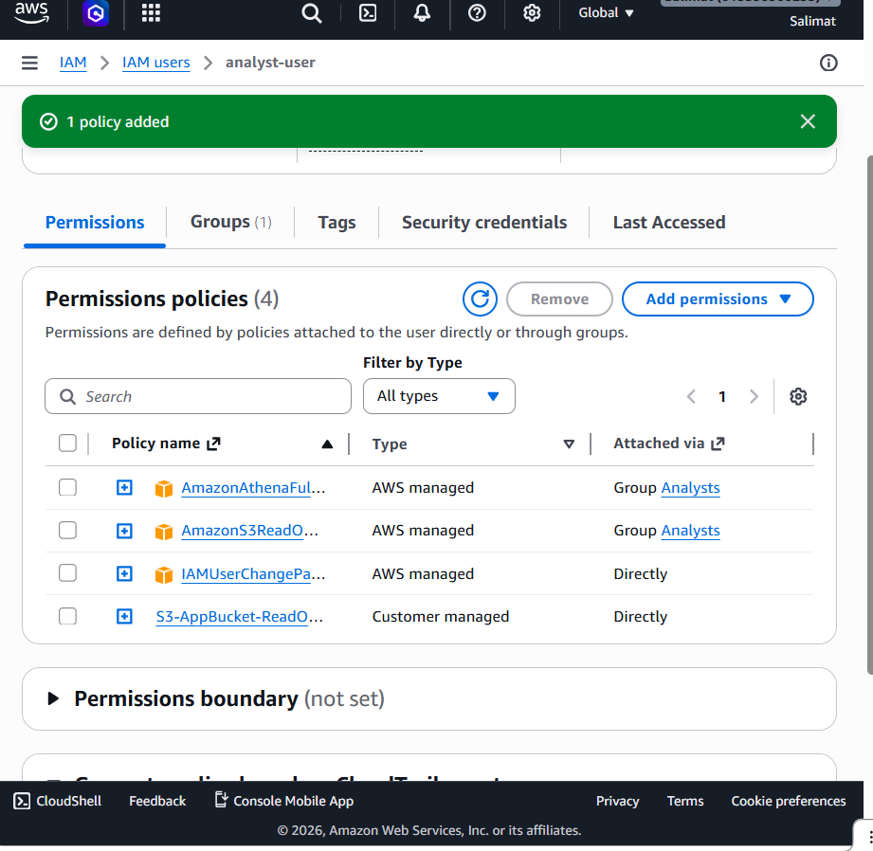
Running the IAM Policy Simulation with the First Resource
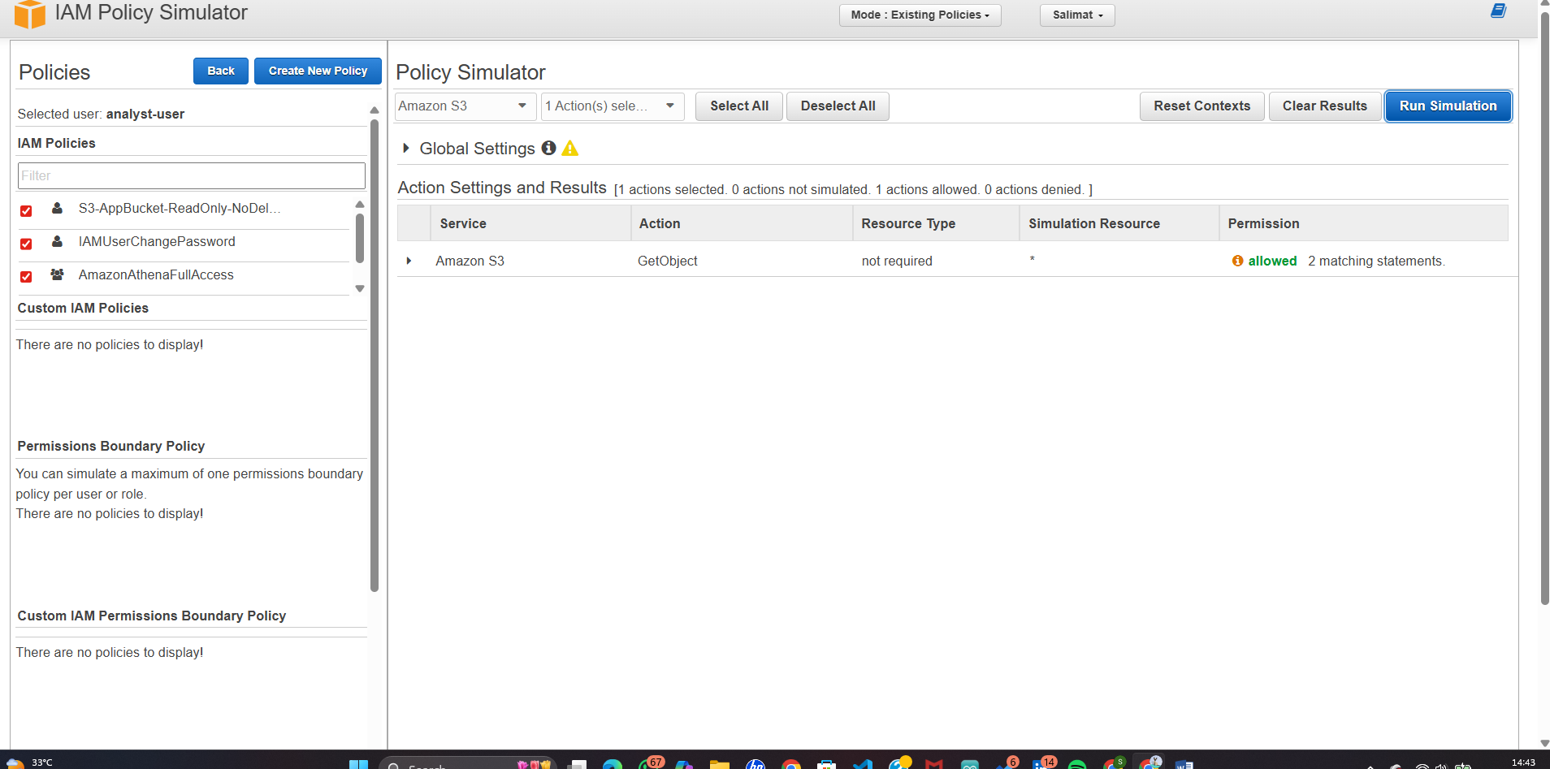
Running the IAM Policy Simulation with the Second Resource
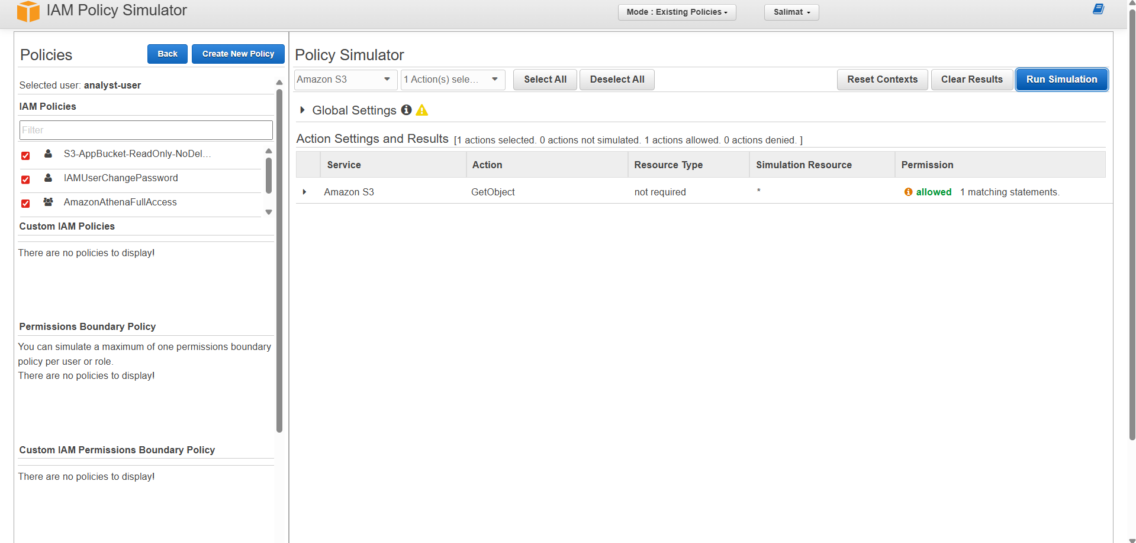
Running the IAM Policy Simulation with the Delete Object Resource
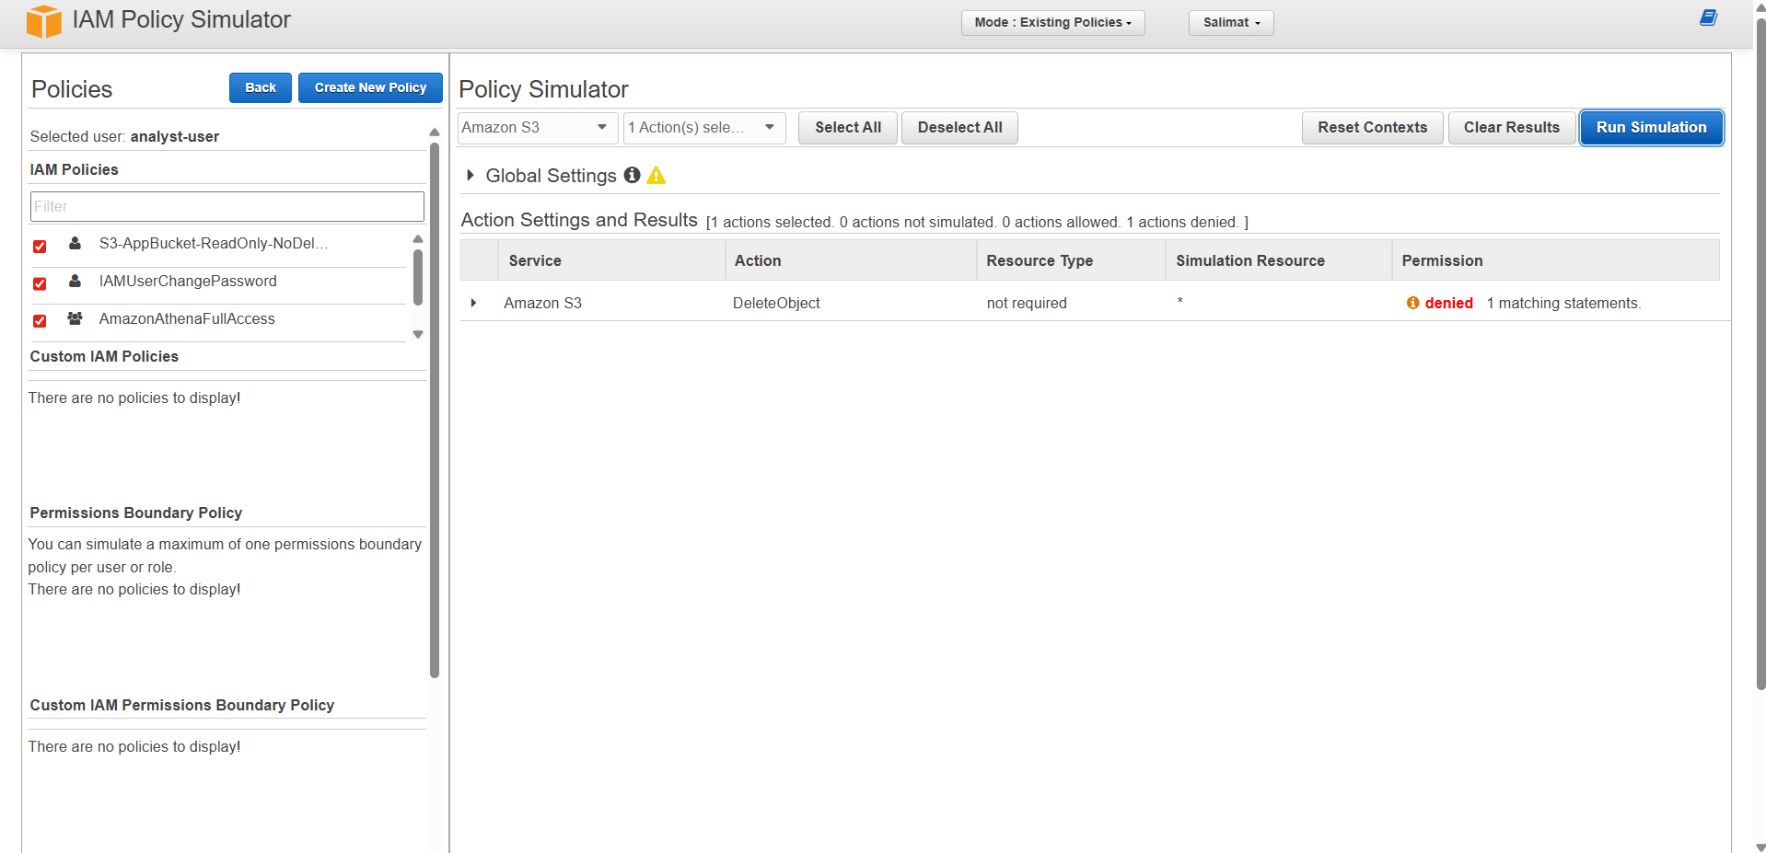

My GitHub Gist Json File Published
https://gist.github.com/Salimahh/92106a957059010246fddb151ea788f6
